Gulf Coast Joint Venture Conservation Planning for Reddish Egret

A Product of the Gulf Coast Joint Venture
Monitoring, Evaluation, and Research Team
Waterbird Working Group

Suggested Citation:
Vermillion, W.G., and B.C. Wilson. 2009. Gulf Coast Joint Venture Conservation Planning for Reddish Egret. Gulf Coast Joint Venture, Lafayette, LA. 18pp.
Gulf Coast Joint Venture Conservation Planning for Reddish Egret

The Reddish Egret (Egretta rufescens) is among the priority species identified for habitat planning, implementation, and evaluation by the Gulf Coast Joint Venture (GCJV) partnership. The North American Waterbird Conservation Plan (NAWCP) ranks Reddish Egret as a species of Moderate Concern, defined as: “Species that are not Highly Imperiled or High Concern. Populations are either a) declining with moderate threats or distributions; b) stable with known or potential threats and moderate to restricted distributions; or c) relatively small with relatively restricted distributions” (Kushlan et al. 2002). The Southeast United States Regional Waterbird Conservation Plan (SE Waterbird Plan), a stepped-down section of the NAWCP relevant to 10 Bird Conservation Regions (BCRs) and portions of 21 states, ranks Reddish Egret as a priority species, at the Immediate Management action level (Hunter et al. 2006). Immediate Management, as defined by Partners in Flight, refers to: “Regional Concern species subject to high regional threats . . . combined with a large population decline . . . Conservation action is needed to reverse or stabilize significant, long-term population declines in species where lack of action may put species at risk of extirpation” (Panjabi et al. 2001). Because of its relatively specialized habitat needs, this species was probably never as abundant as its congeners, however, its population is believed to have been significantly impacted by plume-hunting and other commercial and subsistence harvesting during the early 20th century, and has not rebounded to pre-plume-hunting levels yet (Paul 1991, Lowther and Paul 2002, Hunter et al. 2006). Additional localized population reductions were believed to have been caused by high pesticide levels, and possibly by military training on nesting islands (Paul 1978, 1991). Today, major threats to the species include habitat loss and disturbance by humans (Lowther and Paul 2002).

Species Description

The Reddish Egret is part of the Family Ardeidae, which includes bitterns, herons, and egrets. The species’ range includes the southeastern coastal portion of the United States (South Carolina to Texas); coastal Mexico; the Bahamas and other Caribbean islands; and coastal Belize to coastal Venezuela (Green 2006). Though considered a resident species, some post-breeding dispersal away from breeding colonies is typical, usually involving immature birds (Lowther and Paul 2002). It is a medium sized heron and occurs in two color morphs, a dark (reddish) morph and a white morph. The dark morph is the majority color observed in most parts of the bird’s range (Lowther and Paul 2002).

Reddish Egrets are bush or tree nesting, aquatic stalking carnivores (Hamel 1992). They typically nest in mixed-species colonies on coastal islands and forage in shallow, salt-water habitats. Both natural and artificial (dredge material deposition) islands are used for nesting colony sites (Lowther and Paul 2002). In the GCJV region, plant species used for nest placement include black mangrove (Avicennia germinans), prickly-pear cactus, (Opuntia sp.), Spanish dagger (Yucca sp.), and sea oxeye (Borrichia sp.) (Lowther and Paul 2002, Chaney and Blacklock 2005). The breeding season in the GCJV region ranges from approximately March through July (Green 2006). Figure 1 depicts known Reddish Egret nesting colony sites in the GCJV region. Most birds do not begin breeding
Figure 1. Reddish Egret Nesting Colony Sites, Gulf Coast Joint Venture Region
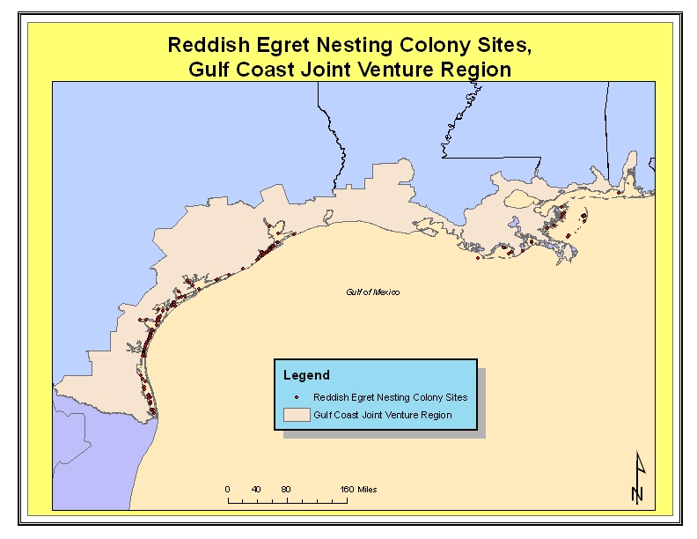

until their fourth year (Lowther and Paul 2002). The species is single-brooded (Lowther
and Paul 2002) and clutch size is typically 3 – 4 (Hamel 1992). The young birds leave the nest at 4-5 weeks of age and are capable of flight at about 7 weeks (Lowther and Paul 2002). Little is known concerning annual survivorship of immature birds (Lowther and Paul 2002).

Foraging habitat in the GCJV region includes wind-driven and lunar tidal flats, barrier island overwash areas, and beaches (Lowther and Paul 2002). Water depths at foraging sites range from 5 – 15 centimeters deep (Lowther and Paul 2002). In Texas, sheepshead minnow (Cyprinodon variegatus) has been shown to be an important prey item for Reddish Egret (Paul 1991, Lowther and Paul 2002). Other prey taken include longnose killifish (Fundulus similis), mullet (Mugil curema, M. cephalus), pinfish (Lagodon rhomboids), and tidewater silverside (Menidia peninsulae) (Paul 1991, Lowther and Paul 2002). The species exhibits a lower foraging success rate than some of its congeners (Rodgers and Smith 1995, Parsons and Miller 2000, Lowther and Paul 2002), perhaps related to differences in foraging habitat prey abundance.

Current Population Estimate and Population Objective

The global population of Reddish Egret is estimated to be 2,500 - 3,000 breeding pairs, or approximately 5,000 – 7,000 individuals, including non-breeding birds (Green 2006). Within the GCJV region, Green (2006) estimated the Texas population at 900 – 950 breeding pairs, the Louisiana population at 60 – 70 breeding pairs, and the Alabama population at 5 – 10 breeding pairs (965 – 1,030 breeding pairs total, GCJV region). The species has not been recorded breeding in Mississippi (Turcotte and Watts 1999, Green 2006). Texas’ breeding population is estimated to account for 30 – 50 percent of the global population of the species (Green 2006).

The SE Waterbird Plan derived estimates for most colonial waterbirds through interviews with state, federal, and other non-government biologists (Hunter et al. 2006). Many cooperators were uncomfortable regarding the accuracy of their estimates, which led the authors of the SE Waterbird Plan to use population size categories representing a range of values. The Reddish Egret population objective from the SE Waterbird Plan is to increase the population from size category 5a (900 < 2,000 breeding pairs) to size category 6 (1,000 – 5,000 breeding pairs) (Hunter et al. 2006). Informed by the SE Waterbird Plan, historical records from the GCJV region, and assumed habitat potential of the region, the GCJV Waterbird Working Group (WbWG) selected a Reddish Egret population objective of 2,100 breeding pairs, with 2,000 breeding pairs in Texas, and 100 in Louisiana, Mississippi, and Alabama combined. The GCJV WbWG also identified availability of suitable nesting sites as the most important factor limiting Reddish Egret population growth in the region, with availability of suitable foraging habitat next in importance.

This document represents an attempt to link regional population targets to their habitat needs through explicit model-based derivations based on factors assumed to currently limit population growth. We also identify evaluation priorities that are directly linked to derivation, and thus refinement, of these desired habitat conditions.

Nesting Habitat

Based on consistently high numbers of nesting pairs per year (mean 50 pairs), Green (2006) identified fifteen key Reddish Egret nesting colony sites throughout the species range. Eight of those sites are located in the GCJV region. Subsequent to that, the GCJV WbWG identified seven additional sites in the GCJV region that merit conservation and/or monitoring actions, due to consistently high numbers of nesting pairs (see Figure 2 below and attached table). Using Green’s (2006) breeding pair estimate for Texas, Louisiana, and Alabama (965 – 1,030), these 15 sites accounted for approximately 83 – 88% of the GCJV region’s nesting pairs from 2002 – 2006. Therefore, we believe that protection, improvement, and maintenance of these sites are important to maintain the GCJV region’s extant population and to increase the population to achieve the objective of 2,100 breeding pairs.

Figure 2. Priority Reddish Egret Sites, GCJV Region
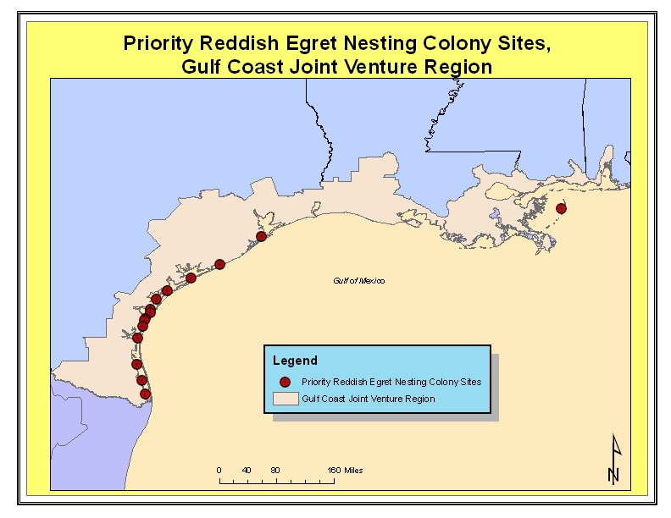

The GCJV WbWG identified six specific actions to protect, improve, and maintain Reddish Egret nesting colony sites:

- Erosion control
- Dredged material placement
- Tree/Shrub planting
- Disturbance management
- Mammalian/Avian predator control
- Fire ant control

For each of the 15 important colony sites identified, the GCJV WbWG determined which of the above actions were currently needed, or likely to be needed in the relatively near future (i.e. 5 – 10 years). For some colonies, additional actions, such as periodic fishing line clean-up, were identified under the category of “Other.”

Protection Actions

Erosion control

Protection of existing important Reddish Egret sites is important to maintaining current population levels. Approximately half of the sites are deemed in need of wave action-induced erosion control measures at this time. Typical erosion control measures include, but are not limited to, geo-tubes, shoreline armoring and nourishing, segmented breakwaters, and artificial reef structures. We assumed that continued erosion will reduce the area of affected sites, and therefore the number of Reddish Egret nesting pairs. Eventually the site could be unsuitable for Reddish Egret nesting. We assumed that addressing erosion on affected sites could mitigate possible losses of 50% of breeding pairs over the next 5-10 years (see attached table).

Improvement Actions

Dredged Material Placement

Dredging to facilitate navigation is a common action in State and Federal waters in the GCJV region. Material removed during dredging operations is often placed on designated sites adjacent to maintained channels, forming islands. Some artificial islands have become tremendously important as colonial waterbird nesting sites. Periodic dredged material placement on or adjacent to these sites and in some instances, on or adjacent to natural islands, can offset the effects of past erosion events, or increase carrying capacity of sites that are not significantly affected by erosion. We assumed that dredge material placement on targeted sites could increase breeding pair use by 25%.

Tree/Shrub Planting

Reddish Egrets typically construct nests on trees or shrubs. Plant species frequently used in the GCJV region include prickly-pear cactus, black mangrove, and sea oxeye. Other species that may provide suitable nesting substrate include false-willow (Baccharis sp.), Texas ebony (Ebanopsis ebano), and granjeno (Celtis pallida) (L. Elliott, 2008, pers comm.). Reddish Egret will nest on the ground as well, but it is probable that ground nests are more susceptible to overwash during storms or extreme tides, and to certain kinds of predation, such as from fire ants or snakes. Woody vegetation on islands is periodically killed by inundation or wave action from storms, erosion, by mechanical action from birds as they prune branches for nest material, and from toxic effects of accumulated guano. At some sites, exotic grasses such as guineagrass (Urochloa maxima) and buffelgrass (Pennisetum ciliare) have encroached in areas of woody vegetation that previously provided substrate for Reddish Egret nesting. The grasses out-compete many preferred plants and eventually establish a monoculture. Since these grasses primarily invade uplands where woody vegetation would otherwise have the best chance of becoming established, removal of an exotic grass monoculture can provide greater area for planting and maintenance of preferred substrate. Repeated treatments, timed during the grasses’ growing season, are usually necessary since the grasses readily regenerate from dormant tillers and seed. Treatment options include chemical and manual methods, and use of fire. At other sites that are not experiencing loss of suitable woody vegetation due to the above factors, there is potential for expanding existing woody vegetation onto other areas and providing increased nest sites. At sites where dredged material deposition occurs, it may be beneficial to plant desirable woody vegetation to provide nesting substrate for Reddish Egrets. Provision of suitable nest substrates is anticipated to enhance Reddish Egret recruitment potential.

Base on expert opinion, familiarity with nesting colony sites, and Chaney and Blacklock’s (2005) rookery island management plan, the GCJV WbWG opined that approximately three-quarters of all important Reddish Egret sites would benefit from placement of dredged material, woody vegetation plantings, or both. We assumed that those actions would result in an approximate 25% increase in breeding pairs at those sites over the next 5-10 years (see attached table).

Maintenance Actions

Disturbance Management

Anthropogenic disturbance is considered to be a significant threat to nesting colonial waterbirds (Kushlan et al. 2002, Chaney and Blacklock 2005, Hunter et al. 2006). Human disturbance can elicit erratic adult behavior causing loss of eggs and death of chicks, provide access for domestic animals, increasing predation levels, and otherwise negatively affect parental care behavior with recruitment consequences (Paul 1991, Hunter et al. 2006). Beyond some threshold of disturbance levels and associated negative consequences, nest and colony site abandonment are possible. This disturbance is often unintentional, occurring during recreational or commercial activity. Human disturbance issues are typically addressed passively, through placement of signs and/or symbolic fencing or actively through patrols from law enforcement officers or wardens. Human disturbance issues can also be addressed through outreach to a targeted segment of the public likely to interact with waterbird colonies. GCJV staff assumed that implementing an effective human disturbance management program could affect a potential 25% increase in Reddish Egret breeding pairs at treated colonies over the next 5-10 years (see attached table). At colonies with disturbance management programs currently in place, we assumed that continuing the programs could mitigate possible losses of 20% of breeding pairs over the next 5-10 years (see attached table).

Predator Control

While some predation is expected at colonial waterbird nesting sites, in certain situations predation can significantly impact colony productivity or lead to colony abandonment. Colonial waterbirds choose islands and other similar isolated habitats where certain types of predators are typically absent or present in low densities. When predators gain access to these sites, their impacts can be substantial (Paul 1991, Coulter and Bryan 1995, Erwin et al. 2001, Chaney and Blacklock 2005, Ellis et al. 2007). Of particular concern are non-native predators [fire ants (Solenopsis invicta), feral house cats (Felis catus), Norway and roof rats (Rattus norvegicus and R. rattus), hogs (Sus scrofa)]; native predators that benefit from anthropogenic habitat changes and occur at relatively high densities, such as raccoon (Procyon lotor) and coyote (Canis latrans); and predation that occurs at sites that host species of conservation concern, or that are experiencing declines in productivity from other sources. Significant predation problems at colonial waterbird sites are typically addressed by lethal or non-lethal trapping methods, exclusion, shooting, or through the use of biocides. Habitat manipulation, such as prescribed burning, is sometimes used to deter or eliminate predators as well. We assumed that implementing an effective predator control program could increase Reddish Egret numbers at treated sites by 50% over the next 5-10 years (see attached table). At colonies with predator control programs currently in place, we assumed that continuing the programs could mitigate possible losses of 33% of breeding pairs over the next 5-10 years (see attached table).

If the 15 important sites are protected, improved, and maintained according to the measures outlined above, we estimate that approximately 63% of the GCJV Reddish Egret population target can be achieved. In the absence of currently applied and recommended measures, we estimate that the Reddish Egret population on these sites will decline by approximately 39% over the next 5-10 years.

Attaining the population target will likely require protecting, improving, and maintaining other GCJV region Reddish Egret nesting colony sites, and/or creating new sites through beneficial use of dredged material. We analyzed 2002-2006 Texas Colonial Waterbird Society (TCWS) data, and information from Louisiana and Alabama to identify sites, besides those listed as priorities above, which averaged hosting at least one nesting Reddish Egret pair (2nd tier sites). If all those 2nd tier sites are in need of all protection, improvement, and maintenance actions identified for priority sites, those actions applied at 2nd tier sites could produce approximately 17% of the GCJV Reddish Egret population target.

Additionally, alternate nesting sites are important for colonial waterbirds during years in which traditional or preferred sites are unsuitable due to factors such as disturbance, high predator densities, and vegetative succession or die-off. Additional sites also appear necessary as a potential means to achieve the remaining 20% of the population target. It would be desirable to have one or more suitable alternate colony sites proximal to the priority Reddish Egret colonies identified above. We have taken an initial step toward identifying and prioritizing suitable alternate sites adjacent to priority Reddish Egret colony sites, using TCWS and other data. Custer et al. (1980) studied heron colonies on the Atlantic coast and documented the mean distance between new and established/stable colonies as 3.8-4.2 km. Consequently, we applied a 5-km buffer around the identified priority Reddish Egret colonies and assumed that 2nd tier sites, and other sites with any history of Reddish Egret use (3rd tier sites), that were inside the buffers would be suitable as alternate sites (Figures 3 – 7 below). This exercise also identified priority Reddish Egret sites that appear to lack suitable alternate sites, suggesting potential priority areas for island creation and/or habitat modification on existing islands. This information should be viewed as preliminary, pending field investigation, as some alternate sites may no longer be extant, and prohibitively difficult and costly to restore.

Foraging Habitat

The GCJV WbWG identified availability of suitable foraging habitat as the second most important factor limiting Reddish Egret population growth. The WbWG also identified the need for a better understanding of optimal foraging habitat characteristics, during both breeding and non-breeding periods, and the needed spatial distribution of foraging habitat in relation to nesting sites. Hydrologic changes caused by dredging and dredged material deposition have rendered some foraging habitat suboptimal to unsuitable (Paul 1991). The shallow-water, near shore habitat utilized by the species has experienced substantial development for recreational and commercial purposes. This development has resulted in outright habitat loss in some cases, or in impaired habitat function in other cases. For example, as coastal Texas’ human population has grown [up ~17.25 percent from 1990 – 2000, (CensusScope 2008)], human disturbance levels have increased. The effect of increased levels of human disturbance at foraging areas is of possible concern. Additionally, impacts related to sea-level changes may also influence the distribution and productivity of foraging habitat, but effects of those changes are not well understood.

Evaluation Priorities

While knowledge concerning some aspects of Reddish Egret life history and habitat requirements is lacking, we believe that conservation actions for the species should proceed. The structure of the GCJV’s iterative conservation planning process is to plan, implement, evaluate, and then re-plan as necessary. The following list is not intended to
Figure 3. Priority Reddish Egret Sites with 5 km Buffer, Laguna Madre Initiative Area (South)
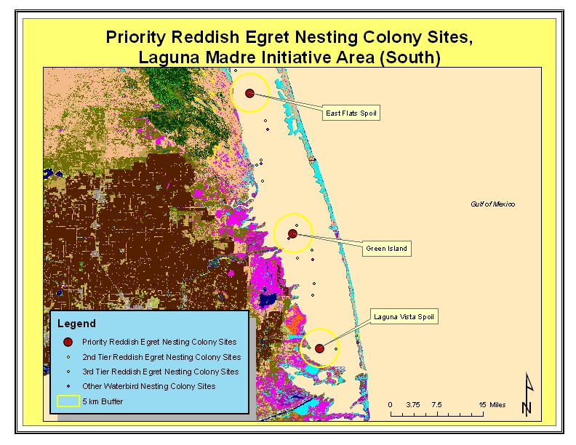

be an enumeration of all important research questions related to Reddish Egrets, but it is
intended to reflect those questions/issues that have the most direct relevance to GCJV habitat objectives and recommended actions for the species.

- The assumptions we have made concerning Reddish Egret population response to protection (erosion control) measures should be validated, and refined as needed.
- The assumptions we have made concerning Reddish Egret population response to improvement measures (i.e. dredged material placement and vegetation management) should be validated, and refined as needed.
- The assumptions we have made concerning Reddish Egret population response to maintenance measures (i.e. disturbance minimization and predator control) should be validated, and refined as needed.

Figure 4. Priority Reddish Egret Sites with 5 km Buffer, Laguna Madre Initiative Area (North)
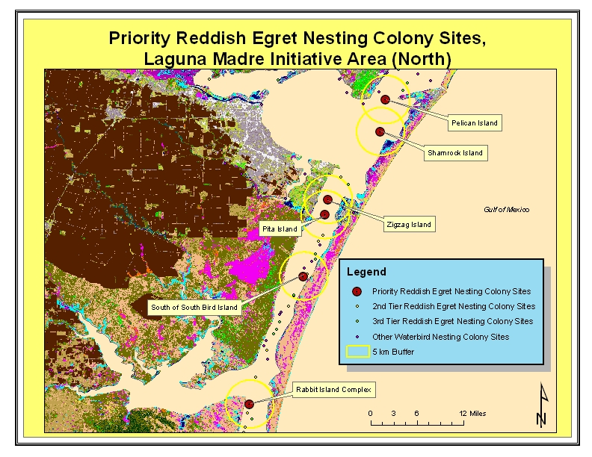

- A better understanding of the physical and spatial characteristics of priority Reddish Egret nesting colony sites could inform and prioritize future management actions at alternate sites, and provide information to be used in creation of bird islands through dredged material deposition.
- Investigations into the appropriate spatial and physical characteristics of alternate nesting sites in relation to priority Reddish Egret nesting sites should be conducted.

Figure 5. Priority Reddish Egret Sites with 5 km Buffer, Texas Mid-Coast Initiative Area (South)
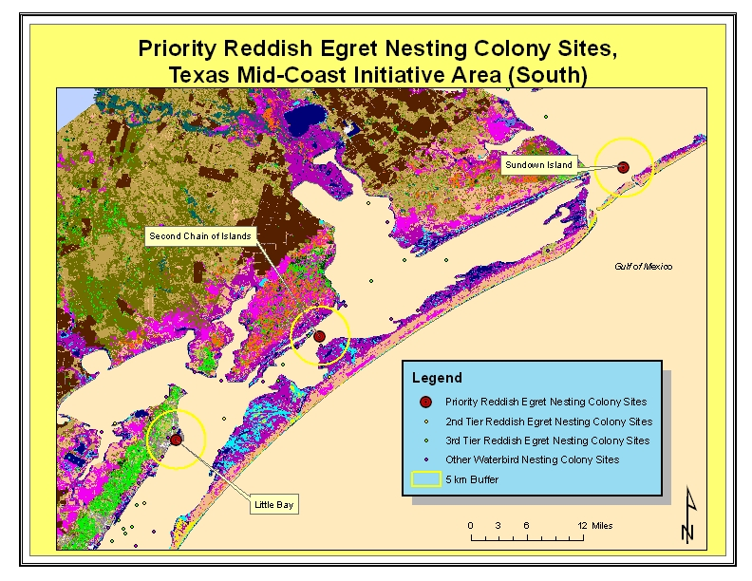

- A better understanding of optimal foraging habitat characteristics is needed, for immature birds, and for both breeding and non-breeding adults. We are currently in need of information to enable estimating the amount of foraging habitat that would be required to support our population objective. Such information needs would include descriptions of specific foraging habitat characteristics, dynamics of foraging flights relative to roosting and/or colony sites, and prey densities within foraging habitats.
- Modeling efforts predicting the effects of sea-level change on the availability, distribution, and productivity of foraging habitat would be valuable.

Figure 6. Priority Reddish Egret Sites with 5 km Buffer, Texas Mid-Coast Initiative Area (North)
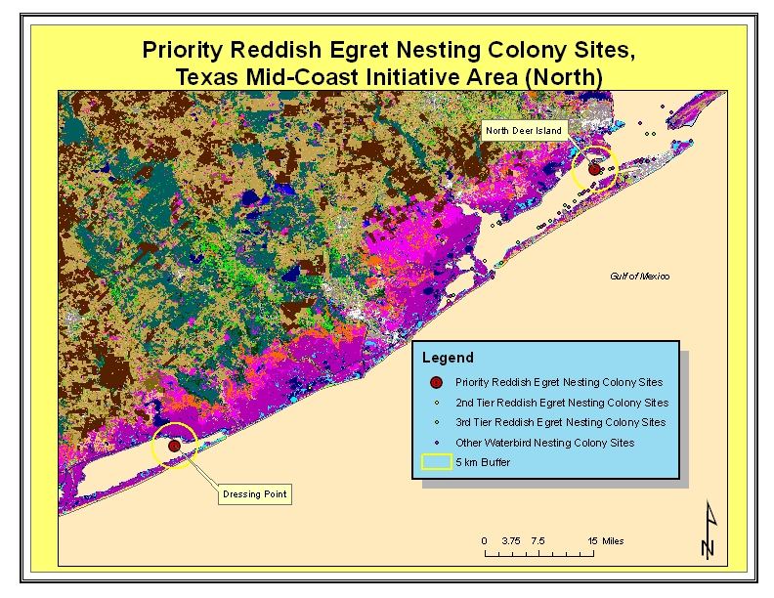

- A better understanding of the impacts of human disturbance at foraging sites is needed. The effects of human disturbance on nesting colonies has been fairly well-documented, but in the face of increased human activities in coastal areas, we do not know to what level those activities are impacting birds’ abilities to effectively forage. If significant diminution of foraging success is occurring due to increased disturbance, there may be consequential impacts on adult survivorship, clutch size, chick survival, etc.
- A better understanding of the possibility that low annual survival (i.e., of post-fledging juveniles and/or adults) may be limiting population growth is warranted. If survival is currently more limiting to population growth than recruitment, alternate or additional conservation measures would be necessary to achieve the desired population response.

Figure 7. Priority Reddish Egret Sites with 5 km Buffer, Mississippi River Coastal Wetlands Initiative Area
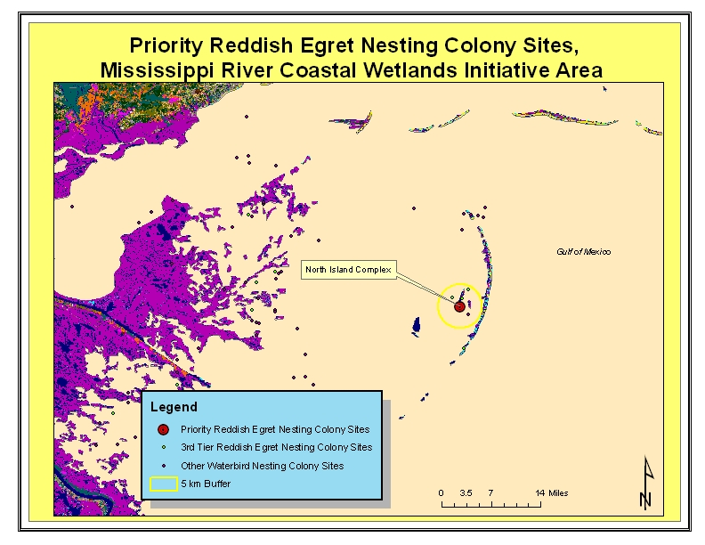

Site Name
State
County or
Parish
Colony #
Ownership or
Management
Entity
1
Recommended
Action
Vital Rate
Relationship
Assumption
2
Recommended
Action
Vital Rate
Relationship
Assumption
2
North Island
LA
St. Bernard
148 150
153
Breton Island NWR
Erosion control
A
Mitigate
possible
losses of
50%
Place dredge material
(opportunities may be
limited)
B
Possible
increase of
25%
Sundown Island
TX
Matagorda
609-300
TXGLO, leased to
NAS
Monitor future conditions
Place dredge material &
monitor need for woody
vegetation planting
B
Possible
increase of
25%
Second Chain
Island
TX
Aransas &
Calhoun
609-422
TXGLO, leased to
NAS
Erosion control on lower
elevation islands
A
Mitigate
possible
losses of
50%
Place dredge material &
plant woody vegetation
(opportunities may be
limited)
B
Possible
increase of
25%
Shamrock Island
TX
Nueces
614-186
TNC
Monitor future conditions
Monitor future conditions
East Flat Spoils
TX
Kenedy
618-120
TXGLO
Monitor future conditions
Monitor future conditions
Green Island
TX
Cameron
618-161
TXGLO, leased to
NAS
Monitor future conditions
Monitor future conditions
Laguna Vista
Spoils
TX
Cameron
618-220
TXGLO, leased to
NAS
Erosion control
A
Mitigate
possible
losses of
50%
Place dredge material &
plant woody vegetation
B
Possible
increase of
25%
Zigzag Island
TX
Nueces
614-222
TXGLO
Erosion control
A
Mitigate
possible
losses of
50%
Place dredge material &
plant woody vegetation
B
Possible
increase of
25%
Pita Island
TX
Nueces
614-300
TXGLO
Monitor future conditions
Plant woody vegetation
B
Possible
increase of
25%
Rabbit Island
Complex
TX
Kleberg
614-362
TXGLO
Erosion control
A
Mitigate
possible
losses of
50%
Place dredge material &
plant woody vegetation
B
Possible
increase of
25%
Pelican Island
TX
Nueces
614-184
POCC; leased to
NAS
Erosion control
A
Mitigate
possible
losses of
50%
Place dredge material &
plant woody vegetation
B
Possible
increase of
25%
South of South
Bird Island
TX
Kleberg
614-341
NPS
Monitor future conditions
Plant woody vegetation
B
Possible
increase of
25%
North Deer
Island
TX
Galveston
600-424
TXGLO, leased to
NAS
Monitor future conditions
Monitor future conditions
Little Bay
TX
Aransas
609-482
ACND
Monitor future conditions
Plant woody vegetation
B
Possible
increase of
25%
Dressing Point
TX
Matagorda
610-160
Big Boggy NWR
Erosion control
A
Mitigate
possible
losses of
50%
Place dredge material
B
Possible
increase of
25%
Recommended Actions for Reddish Egret Populations at Known Important Nest Sites
1
TXGLO = Texas General Land Office; NAS = National Audubon Society; TNC = The Nature Conservancy; POCC= Port of Corpus Christi; TXAS = Texas Audubon
Society; NPS = National Park Service; ACND = Aransas County Navigation District
2
A = Erosion will limit and/or destroy nest sites, thus reducing recruitment potential; B = Improvements will provide additional nesting sites in the future, thus
enhancing recruitment potential; C = Disturbance disrupts parental care, elevates nestling mortality, and/or causes colony abandonment, thus negatively impacting
recruitment; D = Fire ants and certain birds and mammals eat eggs and nestlings, thus negatively impacting recruitment
Expected
Population
Impact
Expected
Population
Impact
Habitat Protection
Habitat Improvement
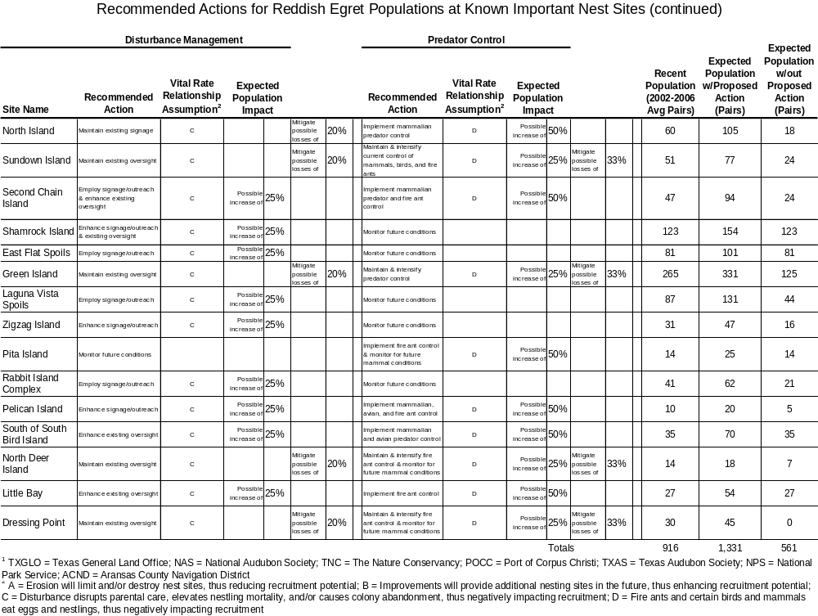
Acknowledgments

The following individuals provided valuable input in the development of this document: current or former GCJV Waterbird Working Group members Dr. Clay Green, Dr. Sammy King, Richard Martin, Stefani Melvin, and Dr. Brent Ortego; David Newstead, Beau Hardegree, Lee Elliott, Michael Brasher, Mark Parr, Dr. Tom Moorman, and Dr. Paul Leberg.

Literature Cited

CensusScope. 2008. Social Science Data Analysis Network, University of Michigan. Available at http://www.CensusScope.org

Chaney, A. H. and G. W. Blacklock. 2005. Colonial waterbird and rookery island management plan. Coastal Bend Bays and Estuaries Program, Corpus Christi, TX. Available at: http://www.cbbep.org

Coulter, M. C. and L. Bryan, Jr. 1995. Factors affecting reproductive success of Wood Storks (Mycteria americana) in east-central Georgia. Auk 112 (1): 237-243, 1995.

Custer, T. W., R. G. Osborn, and W. F. Stout. 1980. Distribution, species abundance, and nesting-site use of Atlantic coast colonies of herons and their allies. Auk 97: 591-600, July 1980.

Ellis, J. C., M. J. Shulman, H. Jessop, R. Suomala, S. R. Morris, V. Seng, M. Wagner, and K. Mach. 2007. Impact of raccoons on breeding success in large colonies of Great Black-backed Gulls and Herring Gulls. Waterbirds. Vol. 30, no. 3, pp. 375-383, September 2007.

Erwin, R. M., B. R. Truitt, and J. E. Jimenez. 2001. Ground-nesting waterbirds and mammalian carnivores in the Virginia barrier island region: running out of options. Journal of Coastal Research. Vol. 17, no. 2, pp. 292-296, Spring 2001.

Green, M. C. 2006. Status report and survey recommendations on the Reddish Egret (Egretta rufescens). U. S. Fish and Wildlife Service, Atlanta, GA. 37 pp.

Hamel, P. B. 1992. Land manager’s guide to the birds of the South. The Nature Conservancy, Southeastern Region, Chapel Hill, NC. 437 pp.

Hunter, W. C., W. Golder, S. Melvin, and J. Wheeler. 2006. Southeast United States regional waterbird conservation plan. Available at: http://www.waterbirdconservation.org/southeast_us.html

Kushlan, J. A., M. J. Steinkamp, K. C. Parsons, J. Capp, M. A. Cruz, M. Coulter, I. Davidson, L. Dickson, N. Edelson, R. Elliot, R. M. Erwin, S. Hatch, S. Kress, R. Milko, S. Miller, K. Mills, R. Paul, R. Phillips, J. E. Saliva, B. Sydeman, J. Trapp, J. Wheeler, and K. Wohl. 2002. Waterbird conservation for the Americas: the North American waterbird conservation plan, version 1. Waterbird Conservation for the Americas, Washington, D. C. 78 pp.

Lowther, P. E. and R. T. Paul. 2002. Reddish Egret (Egretta rufescens), The Birds of North America Online (A. Poole, Ed.). Ithaca, NY: Cornell Lab of Ornithology; Retrieved from the Birds of North America Online: http.//bna.birds.cornell.edu/bna/species/633doi:10.2173/bna.633

Panjabi, A., C. Beardmore, P. Blancher, G. Butcher, M. Carter, D. Demarest, E. Dunn, C. Hunter, D. Pashley, K. Rosenberg, T. Rich, and T. Will. 2001. The Partners in Flight handbook on species assessment & prioritization, version 1.1. Available at: http://www.rmbo.org/pubs/downloads/Handbook.pdf

Parsons, K. C. and T. L. Master. 2000. Snowy Egret (Egretta thula), The Birds of North America Online (A. Poole, Ed.). Ithaca: Cornell Lab of Ornithology; Retreived from the Birds of North America Online: http://bna.birds.cornell.edu/bna/species/489

Paul, R. T. 1991. Status report – Egretta rufescens (Gmelin) Reddish Egret. U.S. Fish and Wildlife Service, Houston, TX. 73 pp.

Rodgers, J. A., Jr. and H. T. Smith. 1995. Little Blue Heron (Egretta caerulea). The Birds of North America Online (A. Poole, Ed.). Ithaca: Cornell Lab of Ornithology; Retreived from the Birds of North America Online: http://bna.birds.cornell.edu/bna/species/145

Turcotte, W. H. and D. L. Watts. 1999. Birds of Mississippi. Mississippi Department of Wildlife, Fisheries, and Parks. University Press of Mississippi, Jackson, MS. 455 pp.

